**Model Database**

Table of Contents

Conceptual Model 3

Relational Model 4

Tables Characteristics 5

Table Descriptions 11

# Conceptual Model

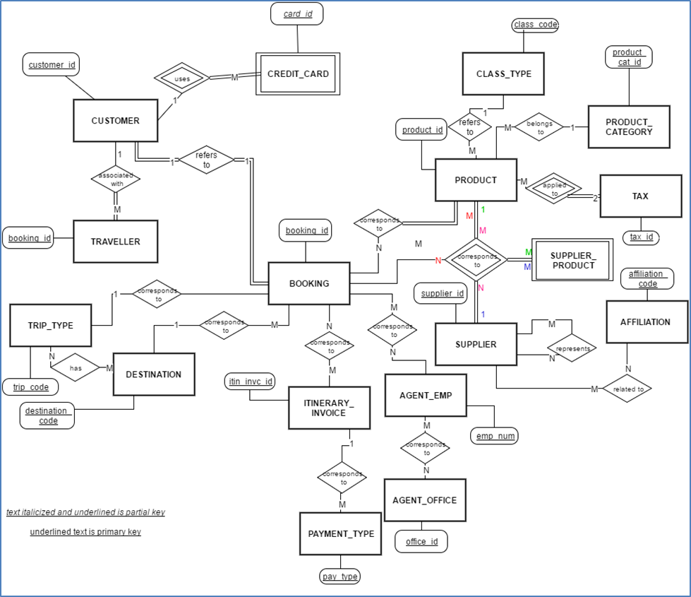

# Relational Model

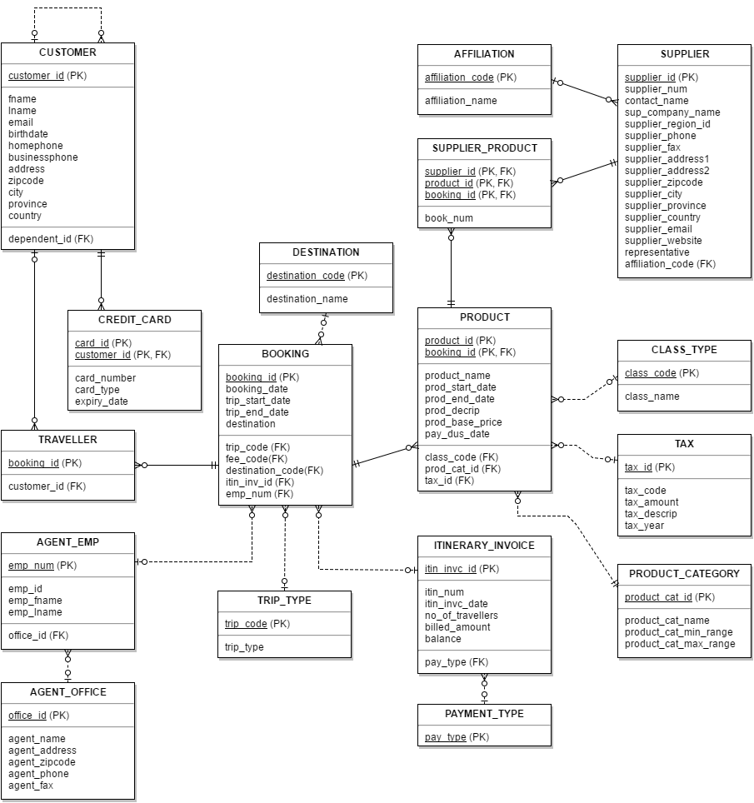

# Tables Characteristics

|  |  |  |  |  |  |  |  |  |  |
| --- | --- | --- | --- | --- | --- | --- | --- | --- | --- |
| **CUSTOMER:** | | | | | | | | | |
| **Column Name** | **Key Type** | **Nulls/**  **Unique** | **FK Ref Table** | **FK Ref Columns** | **Data Type** | **Max Length** | **Sample Data 1** | **Sample Data 2** | **Sample Data 3** |
| **customer_id** | PK |  |  |  | NUMBER |  | 106 | 121 | 379 |
| **customer_fname** |  |  |  |  | VARCHAR2 | 15 | Judith | Sean | Craig |
| **customer_lname** |  |  |  |  | VARCHAR2 | 15 | Olvsade | Pinade | Padron |
| **customer_birth_date** |  |  |  |  | DATE |  | 22/06/1955 | 27/05/1971 | 21/09/1955 |
| **customer_home_phone** |  |  |  |  | CHARACTER | 12 | 4032795652 | 4032691954 | 4036865588 |
| **customer_business_phone** |  |  |  |  | CHARACTER | 12 | 4036861598 | 4036864444 | 4036862587 |
| **customer_email** |  |  |  |  | VARCHAR2 | 40 | [jolvsade@aol.com](mailto:jolvsade@aol.com) | [spineda@hotmail.com](mailto:spineda@hotmail.com) | [craigpadron@msn.com](mailto:craigpadron@msn.com) |
| **customer_address** |  |  |  |  | VARCHAR2 | 40 | 29 Elmwood Ave., | 3 Salem Rd., NW | 199-46 21st Ave., SW |
| **customer_zipcode** |  |  |  |  | CHARACTER | 10 | T2Z 3M9 | T2K 3E3 | T2P 2G7 |
| **customer_city** |  |  |  |  | VARCHAR2 | 30 | Calgary | Toronto | Vancouver |
| **customer_province** |  |  |  |  | VARCHAR2 | 20 | Alberta | Ontario | Quebec |
| **customer_Country** |  |  |  |  | VARCHAR2 | 30 | Canada | Canada | Canada |
| **cust_special_date** |  |  |  |  | DATE |  | 22/06/1955 | 27/05/1971 | 21/09/1955 |
| **Special_date_desc** |  |  |  |  | VARCHAR2 | 40 | Anniversary | Birth Day | Graduation |
| **Cust_dependent** | FK |  | CUSTOMER | Customer_id | NUMBER |  | 106 | 121 | 379 |

|  |  |  |  |  |  |  |  |  |  |
| --- | --- | --- | --- | --- | --- | --- | --- | --- | --- |
| **TRAVELLER:** | | | | | | | | | |
| **Column Name** | **Key Type** | **Nulls/**  **Unique** | **FK Ref Table** | **FK Ref Columns** | **Data Type** | **Maximum Length** | **Sample Data 1** | **Sample Data 2** | **Sample Data 3** |
| **customer_id** | PK |  | CUSTOMER | FK | NUMBER |  | 106 | 121 | 379 |
| **booking_id** | FK |  | BOOKING | FK | NUMBER |  | JK8I | FD33 | 56565T |

|  |  |  |  |  |  |  |  |  |  |
| --- | --- | --- | --- | --- | --- | --- | --- | --- | --- |
| **CREDIT_CARD** | | | | | | | | | |
| **Column Name** | **Key Type** | **Nulls/**  **Unique** | **FK Ref Table** | **FK Ref Columns** | **Data Type** | **Maximum Length** | **Sample Data 1** | **Sample Data 2** | **Sample Data 3** |
| **card_id** | PK |  |  |  | NUMBER |  | 981 | 105 | 766 |
| **card_number** |  |  |  |  | NUMBER |  | 99834387984533 | 8674863489648960 | 2343134123431340 |
| **expiry_date** |  |  |  |  | DATE |  | 05/11/2005 | 29/09/2011 | 03/02/2010 |
| **customer_id** | FK, PK |  | CUSTOMER | customer_id | NUMBER |  | 106 | 121 | 379 |

|  |  |  |  |  |  |  |  |  |  |
| --- | --- | --- | --- | --- | --- | --- | --- | --- | --- |
| **BOOKING:** | | | | | | | | | |
| **Column Name** | **Key Type** | **Nulls/**  **Unique** | **FK Ref Table** | **FK Ref Columns** | **Data Type** | **Max Length** | **Sample Data 1** | **Sample Data 2** | **Sample Data 3** |
| **booking_id** | PK |  |  |  | NUMBER |  | 56565T | FD333 | JK8I |
| **booking_date** |  |  |  |  | DATE |  | 17/06/2008 | 08/05/2009 | 01/10/2010 |
| **trip_start_date** |  |  |  |  | DATE |  | 25/05/2008 | 12/03/2009 | 16/07/2009 |
| **trip_end_date** |  |  |  |  | DATE |  | 22/06/2008 | 17/03/2009 | 30/07/2009 |
| **Destination_desc** |  |  |  |  | VARCHAR2 | 50 | Calgary, Paris, London | Montreal, Amsterdam, Paris, Rome | Toronto, Chicago, Miami |
| **destination_code** | FK |  | DESTINATION |  | VARCHAR2 | 10 | EU | EU | NA |
| **trip_code** | FK |  | TRIP_TYPE |  | VARCHAR2 | 2 | FR | FR | PER |
| **emp_num** | FK |  | AGENT_EMP |  | NUMBER |  | 1 | 2 | 3 |
| **Itin_invc_id** | FK |  | ITINERARY_INVOICE |  | NUMBER |  | 1004 | 2564 | 9876 |

|  |  |  |  |  |  |  |  |  |  |
| --- | --- | --- | --- | --- | --- | --- | --- | --- | --- |
| **DESTINATION:** | | | | | | | | | |
| **Column Name** | **Key Type** | **Nulls/**  **Unique** | **FK Ref Table** | **FK Ref Columns** | **Data Type** | **Maximum Length** | **Sample Data 1** | **Sample Data 2** | **Sample Data 3** |
| **destination_code** | PK |  |  |  | VARCHAR2 | 10 | EU | NA | AFR |
| **destination_name** |  |  |  |  | VARCHAR2 | 30 | Europe and United kingdom | North America | Africa |

|  |  |  |  |  |  |  |  |  |  |
| --- | --- | --- | --- | --- | --- | --- | --- | --- | --- |
| **TRIP_TYPE:** | | | | | | | | | |
| **Column Name** | **Key Type** | **Nulls/**  **Unique** | **FK Ref Table** | **FK Ref Columns** | **Data Type** | **Maximum Length** | **Sample Data 1** | **Sample Data 2** | **Sample Data 3** |
| **trip_type_id** | PK |  |  |  | NUMBER |  | B | L | G |
| **trip_type** |  |  |  |  | VARCHAR2 | 10 | Business | Leisure | Group |

|  |  |  |  |  |  |  |  |  |  |
| --- | --- | --- | --- | --- | --- | --- | --- | --- | --- |
| **AFFILIATION:** | | | | | | | | | |
| **Column Name** | **Key Type** | **Nulls/**  **Unique** | **FK Ref Table** | **FK Ref Columns** | **Data Type** | **Maximum Length** | **Sample Data 1** | **Sample Data 2** | **Sample Data 3** |
| **affiliation_code** | PK |  |  |  | VARCHAR2 | 10 | 1 | 2 | 3 |
| **affiliation_name** |  |  |  |  | VARCHAR2 | 30 | ACTA | ACTANEW | ACTANEWP |

|  |  |  |  |  |  |  |  |  |  |  |
| --- | --- | --- | --- | --- | --- | --- | --- | --- | --- | --- |
| **SUPPLIER:** | | | | | | | | | | |
| **Column Name** | **Key Type** | **Nulls/**  **Unique** | **FK Ref Table** | **FK Ref Columns** | | **Data Type** | **Max**  **Length** | **Sample Data 1** | **Sample Data 2** | **Sample Data 3** |
| **supplier_id** | PK |  |  |  | NUMBER | |  | 412 | 457 | 845 |
| **region_id** |  |  |  |  | CHAR | | 2 | 1 | 1 | 2 |
| **sup_company_name** |  |  |  |  | VARCHAR2 | | 20 | GOTTA TRAVEL! TOURS | BUTTERFIELD & ROBINSON | DISCOVER THE WORLD MARKETING |
| **sup_contact_ fname** |  |  |  |  | VARCHAR2 | | 20 | Paul | George | Joanne |
| **sup_contact_ lname** |  |  |  |  | VARCHAR2 | | 20 | Marner | Butterfield | Lundy |
| **supplier_phone** |  |  |  |  | CHARACTER | | 15 | 4169419100 | 4168641354 | 9058910093 |
| **supplier_fax** |  |  |  |  | CHARACTER | | 15 | 4169419119 | 4168640541 | 9058918026 |
| **supplier_address1** |  |  |  |  | VARCHAR2 | | 20 | 19 River St | 70 Bond St | 1599 Hurontario St |
| **supplier_address2** |  |  |  |  | VARCHAR2 | | 20 | Suite 203 | Suite 300 | Suite 100 |
| **supplier_zipcode** |  |  |  |  | CHARACTER | | 7 | M5A 3P1 | M5B 1X3 | L5G 4S1 |
| **supplier_city** |  |  |  |  | VARCHAR2 | | 30 | Calgary | toronto | Vancouver |
| **supplier_province** |  |  |  |  | VARCHAR2 | | 20 | Alberta | Ontario | Quebec |
| **supplier_country** |  |  |  |  | VARCHAR2 | | 30 | Canada | USA | Italy |
| **supplier_email** |  |  |  |  | VARCHAR2 | | 30 | [paul@gottatravel.com](mailto:paul@gottatravel.com) | [info@butterfield.com](mailto:info@butterfield.com) | <toronto@discovertheworld.ca> |
| **supplier_website** |  |  |  |  | VARCHAR2 | | 30 | <http://www.gottatravel.com> | [http://www.butterfield.com](http://www.butterfield.com/) |  |
| **representative** |  |  |  |  | VARCHAR2 | | 20 | TAKEATRIP | ENCORE CRUISES | WORLD IN YOUR HANDS |
| **affiliation_code** | FK |  | AFFILIATION | **affiliation_code** | VARCHAR2 | | 10 | 1 | 2 | 3 |

|  |  |  |  |  |  |  |  |  |  |
| --- | --- | --- | --- | --- | --- | --- | --- | --- | --- |
| **SUPPLIER_PRODUCT:** | | | | | | | | | |
| **Column Name** | **Key Type** | **Nulls/**  **Unique** | **FK Ref Table** | **FK Ref Columns** | **Data Type** | **Maximum Length** | **Sample Data 1** | **Sample Data 2** | **Sample Data 3** |
| **supplier_id** | PK |  | SUPPLIER | FK | NUMBER |  | 412 | 457 | 845 |
| **product_id** | PK |  | PRODUCT | FK | NUMBER |  | 12301 | 45672 | 98872 |
| **booking_id** | PK |  | BOOKING | FK | NUMBER |  | 245 | 5546 | 57687 |

|  |  |  |  |  |  |  |  |  |  |
| --- | --- | --- | --- | --- | --- | --- | --- | --- | --- |
| **PRODUCT:** | | | | | | | | | |
| **Column Name** | **Key Type** | **Nulls/**  **Unique** | **FK Ref Table** | **FK Ref Columns** | **Data Type** | **Max Length** | **Sample Data 1** | **Sample Data 2** | **Sample Data 3** |
| **product_id** | PK |  |  |  | NUMBER |  | 12301 | 45672 | 98872 |
| **booking_id** | PK |  | BOOKING | FK | NUMBER |  | 245 | 5546 | 57687 |
| **prod_name** |  |  |  |  | VARCHAR2 | 20 | USTours | AirCanada | Travel Insurance |
| **Prod_start_date** |  |  |  |  | DATE |  | 17/06/08 | 08/05/09 | 01/11/10 |
| **Prod_end_date** |  |  |  |  | DATE |  | 17/06/08 | 08/05/09 | 01/11/10 |
| **Prod_description** |  |  |  |  | VARCHAR2 | 40 | Calgary/Maui | Airline | All inclusive |
| **Prod_base_price** |  |  |  |  | NUMBER | (10,2) | $ 150.00 | $ 598.00 | $ 73.00 |
| **Pay_due_date** |  |  |  |  | DATE |  | 17/06/08 | 08/05/09 | 01/11/10 |
| **Class_code** |  |  |  |  | VARCHAR2 | 10 | FST | BSN | ECN |
| **prod_cat_id** |  |  | PRODUCT_CATEGORY | FK | NUMBER |  | 9 | 2 | 10 |
| **tax_id** | PK |  |  |  | NUMBER |  | 1 | 2 | 3 |

|  |  |  |  |  |  |  |  |  |  |
| --- | --- | --- | --- | --- | --- | --- | --- | --- | --- |
| **CLASS_TYPE:** | | | | | | | | | |
| **Column Name** | **Key Type** | **Nulls/**  **Unique** | **FK Ref Table** | **FK Ref Columns** | **Data Type** | **Maximum Length** | **Sample Data 1** | **Sample Data 2** | **Sample Data 3** |
| **class_type_code** | PK |  |  |  | VARCHAR2 | 10 | FS | BSN | ECN |
| **class_type_name** |  |  |  |  | CHARACTER | 15 | First Class | Business | Economy |

|  |  |  |  |  |  |  |  |  |  |
| --- | --- | --- | --- | --- | --- | --- | --- | --- | --- |
| **PRODUCT_CATEGORY:** | | | | | | | | | |
| **Column Name** | **Key Type** | **Nulls/**  **Unique** | **FK Ref Table** | **FK Ref Columns** | **Data Type** | **Maximum Length** | **Sample Data 1** | **Sample Data 2** | **Sample Data 3** |
| **product_cat_id** | PK |  |  |  | NUMBER |  | 2 | 9 | 10 |
| **product_cat_name** |  |  |  |  | VARCHAR2 | 35 | Airlines | Tour Operators/Wholesales | Travel Insurance |
| **product_cat_min_range** |  |  |  |  | NUMBER |  | 150 | 500 | 550 |
| **product_cat_max_range** |  |  |  |  | NUMBER |  | 199 | 549 | 559 |

|  |  |  |  |  |  |  |  |  |
| --- | --- | --- | --- | --- | --- | --- | --- | --- |
| **TAX:** | | | | | | | | |
| **Column Name** | **Key Type** | **Nulls/**  **Unique** | **FK Ref Table** | **FK Ref Columns** | **Data Type** | **Maximum Length** | **Sample Data 1** | **Sample Data 2** |
| **tax_id** | PK |  |  |  | NUMBER |  | 1 | 2 |
| **tax_code** |  |  |  |  | VARCHAR2 | 10 | GST | PST |
| **tax_type** |  |  |  |  | VARCHAR2 | 10 | Governmental | Provincial |
| **tax_description** |  |  |  |  | BFILE |  | Governmental tax rates | Provincial tax rates |
| **Tax_year** |  |  |  |  | DATE |  | 17/06/08 | 08/05/09 |

|  |  |  |  |  |  |  |  |  |  |
| --- | --- | --- | --- | --- | --- | --- | --- | --- | --- |
| **ITINERARY_INVOICE:** | | | | | | | | | |
| **Column Name** | **Key Type** | **Nulls/**  **Unique** | **FK Ref Table** | **FK Ref Columns** | **Data Type** | **Maximum Length** | **Sample Data 1** | **Sample Data 2** | **Sample Data 3** |
| **Itin_invc_id** | PK |  |  |  | NUMBER |  | 1004 | 2564 | 9876 |
| **Itinerary_num** |  |  |  |  | NUMBER |  | 210 | 3995 | 398795 |
| **Itin_invc_date** |  |  |  |  | DATE |  | 08/05/11 | 10/03/07 | 06/23/09 |
| **no_of_travellers** |  |  |  |  | NUMBER |  | 2 | 3 | 1 |
| **billed_amount** |  |  |  |  | NUMBERPS | 10,2 | $ 450.00 | $ 125.00 | $ 560.00 |
| **balance** |  |  |  |  | NUMBERPS | 10,2 | $ 450.00 | $ 125.00 | $ 560.00 |
| **pay_type** | FK |  | TRIP_TYPE | pay_type | VARCHAR2 |  | FINAL PAYMENT | FULL PAYMENT | DEPOSIT |

|  |  |  |  |  |  |  |  |  |  |
| --- | --- | --- | --- | --- | --- | --- | --- | --- | --- |
| **PAYMENT_TYPE:** | | | | | | | | | |
| **Column Name** | **Key Type** | **Nulls/**  **Unique** | **FK Ref Table** | **FK Ref Columns** | **Data Type** | **Maximum Length** | **Sample Data 1** | **Sample Data 2** | **Sample Data 3** |
| **pay_type** | PK |  |  |  | VARCHAR2 | 15 | deposits | final payments | full payments |

|  |  |  |  |  |  |  |  |  |  |
| --- | --- | --- | --- | --- | --- | --- | --- | --- | --- |
| **AGENT_EMP:** | | | | | | | | | |
| **Column Name** | **Key Type** | **Nulls/**  **Unique** | **FK Ref Table** | **FK Ref Columns** | **Data Type** | **Maximum Length** | **Sample Data 1** | **Sample Data 2** | **Sample Data 3** |
| **emp_num** | PK |  |  |  | NUMBER |  | 11 | 12 | 13 |
| **emp _id** |  |  |  |  | VARCHAR | 3 | JD | JL | DR |
| **emp _fname** |  |  |  |  | VARCHAR2 | 15 | Janet | Judy | Dennis C. |
| **emp _lname** |  |  |  |  | VARCHAR2 | 15 | Delton | Lisle | Reynolds |
| **Office_id** | FK |  | AGENT_OFFICE | **Office_id** | NUMBER |  | 1 | 2 | 3 |

|  |  |  |  |  |  |  |  |  |  |
| --- | --- | --- | --- | --- | --- | --- | --- | --- | --- |
| **AGENT_OFFICE** | | | | | | | | | |
| **Column Name** | **Key Type** | **Nulls/**  **Unique** | **FK Ref Table** | **FK Ref Columns** | **Data Type** | **Maximum Length** | **Sample Data 1** | **Sample Data 2** | **Sample Data 3** |
| **Office_id** | PK |  |  |  | NUMBER |  | 1 | 2 | 3 |
| **agent_name** |  |  |  |  | VARCHAR2 | 25 | Travel Experts |  |  |
| **agent_address** |  |  |  |  | VARCHAR2 | 50 | 130, 16 Ave, SW |  |  |
| **agent_zipcode** |  |  |  |  | VARCHAR2 | 10 | T3G 1B1 | T2R 1N1 | Z7Y 2M2 |
| **agent_phone** |  |  |  |  | VARCHAR2 | 18 | 4032294372 |  |  |
| **agent_fax** |  |  |  |  | VARCHAR2 | 18 | 4033345687 |  |  |

# Table Descriptions

|  |  |
| --- | --- |
| **ENTITY_NAME** | **DESCRIPTION** |
| **CUSTOMER** | A customer is a person who intends to book his trip in the Travel Experts  agency. There are two customer categories: Corporate, and Leisure  - Each CUSTOMER must be *associated with* zero or more  TRAVELLER who wants to travel with him/her  - A CUSTOMER may use one or more CREDIT_CARD for payment |
| **CREDIT_CARD** | Each CUSTOMER may use a CREDIT_CARD to pay bills.  - each CREDIT_CARD must belong to a CUSTOMER |
| **TRAVELLER** | Each CUSTOMER may have a trip with zero or more  passengers/travellers.  - Each TRAVELLER must correspond to a CUSTOMER  - Each TRAVELLER must have a booking number in BOOKING |
| **BOOKING** | This contains all information regarding a booked trip. For each booked trip there is a record of detail information which is an agreement between the agency, customer, and suppliers  - Each BOOKING must refer to a CUSTOMER with zero or more TRAVELLERs  - Each BOOKING may correspond to a DESTINATION  - Each BOOKING must correspond to one or more PRODUCTs  - Each BOOKING may correspond to a TRIP_TYPE  - Each BOOKING may correspond to one or more ITINERARY_INVOICE |
| **TRIP_TYPE** | Each TRIP_TYPE may be categorized as one of leisure, business, or  group.  - Each TRIP_TYPE may represent one or more ITINERARY_INVOICE |
| **DESTINATION** | Each trip has a final destination. This entity has a 1:N relationship with  BOOKING |
| **AFFILIATION** | - Each AFFILIATION may be related to one or more SUPPLIER |
| **SUPPLIER** | A supplier is a company that provides one or more products for agency to  sell to customers. Suppliers may be located around the world but they  mostly have a representative in North America  - Each SUPPLIER may be represented by another SUPPLIER, who in  turn may be represented by itself  - Each SUPPLIER must provide one or more products in  SUPPLIER_PRODUCT which is related to a booked trip  - Each SUPPLIER may be associated with one or more AFFILIATION |
| **SUPPLIER_PRODUCT** | A SUPPLIER_PRODUCT represents the relationship among a supplier,  its products, and booking number.  - Each SUPPLIER_PRODUCT must correspond to only one SUPPLIER  - Each SUPPLIER_PRODUCT must correspond to one PRODUCT only |

|  |  |
| --- | --- |
| **ENTITY_NAME** | **DESCRIPTION** |
| **TAX** | Taxes are divided into two categories: GST (government tax rates), PST  (provincial tax rate)  - Each TAX type must be applied to one or more PRODUCT |
| **CLASS_TYPE** | There are different classes of products, which include First class,  Business class, and Economy class.  - Each CLASS_TYPE may correspond to one or more PRODUCT |
| **PRODUCT** | A product is provided by a supplier to be given to a customer through  different agencies.  - Each PRODUCT must correspond to one or more SUPPLIER  - Each PRODUCT must correspond to one or more BOOKING  - Each PRODUCT may correspond to one or more COMMISSION  - Each PRODUCT may have applied to it zero or more TAX  - Each PRODUCT may belong to a PRODUCT_CATEGORY |
| **PRODUCT_CATEGORY** | Products are divided into eleven or more different categories: airline  consolidators, airlines, attractions, car rentals, cruise lines, hotel  reps&chains in Canada, motor coach tour operators, railroads, tour  operators/wholesales, travel insurance, yacht & boat charters,  - Each PRODUCT_CATEGORY may represent one or more PRODUCT |
| **ITINERARY_INVOICE** | An itinerary represents a trip taken by a customer and one or more people  may travel under the same itinerary. Also, many products may be part of  a single itinerary.  - Each ITINERARY_INVOICE may correspond to one or more  BOOKING  - Each ITINERARY_INVOICE may correspond to one  PAYMENT_TYPE |
| **AGENT_EMP** | An agency constitutes of four senior agents, six intermediate agents, and  six junior agents. There is also a travel agency manager at each agency.  Agents provide different products and services related to a trip for their  customers.  - Each AGENT_EMP(LOYEE) may correspond to one or more  BOOKING  - Each AGENT_EMP may correspond to an AGENT_OFFICE |
| **AGENT_OFFICE** | Currently there is only one office but it is possible in the future for this to  increase.  - Each AGENT_OFFICE may correspond to one or more AGENT_EMP |